ESL Speaking Skills III (Formerly Speaking Up)

TOPIC: Conveying Information

APPLICABLE COURSES: All (but designed for non-native speakers)

LEARNING OUTCOME: (What will students be able to do by the end of the workshop?)

Students will be able to identify strategies to communicate information accurately.
Students will be able to identify pronunciation mistakes.

CONTENT: (What do students need to know to accomplish the outcome?)
Some English.
Basic Sentence structure in spoken English

METHOD: (How will the instructor deliver content? Short lecture, handouts, Powerpoint, other audio-visual presentation)
Handout on talking about movies
Youtube Clip – Berlitz Miscommunication

http://video.google.com/videoplay?docid=-4285735180713973313&ei=oXRmS6SWE5qEqQOAiaCICA&q=video+clips+showing+miscommunication&client=firefox-a#

ACTIVE LEARNING STRATEGIES: (How will students apply their knowledge? Solve a problem, create a project, analyze a case, explain a process?)

Information Gap Activity
Students receive either handout A or handout B
In pairs, Ss work together to complete the missing information in their handout.

Ss use red telephones that provide simultaneous listening of their pronunciation when their partner doesn’t understand them.
Red telephones are red telephone sets that give immediate playback of your voice. You use them by speaking into one.

Discussion – Refer to Strategies for Making Oneself understood Handout
How did you convey the information?
What did you do when the student didn’t know the word?
How did you describe what you meant?
How does this connect to your regular language worlds?

This keeps going depending on time and numbers.

ASSESSMENT METHOD: (How will the instructor know that the students met the outcome? Check for understanding.)
Students will be informally assessed during the activity portion of the workshop.
Ss must present two or three sentences to the class about how to convey information.

SELF-REFLECTION ACTIVITY: (What will the instructor do to get students to reflect on how they learned the content? What they learned, how they learned it, how they will apply it in their coursework)

Students will talk or write about the difficulties they have in making themselves understood. They will reflect on the strategies they used during the activity (materials III handout).

ESL Speaking Skills III Materials

Strategies for making oneself understood

Which of the following did you use during the activity?

Circumlocution – talk around the word
Gestures
Language One (native language)
Explanation
Examples
Complete sentences
Changing pronunciation

Other?

Which were the most effective?

A Sheet: Do You Feel Like Seeing a Movie?
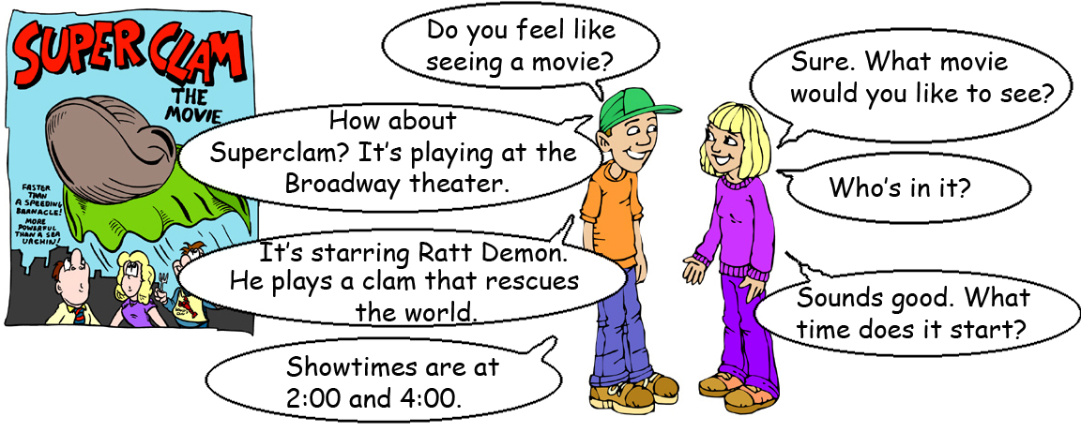
Practice the dialogue with a partner. Fill in the missing information.
 | Location:  Synopsis:  Showtimes: |  | Location:  Caprice Theater  Synopsis:  Jenny Roberts plays a penguin that travels through space.  Showtimes:  6:45, 8:45
 | Location:  Metro Theater  Synopsis:  Arnold Stallone plays a soldier who saves New York from terrorists.  Showtimes:  2:00, 5:00, 9:30 |  | Location:  Synopsis:  Showtimes:
 | Location:  Synopsis:  Showtimes: |  | Location:  Filberg Theater  Synopsis:  Christina Spears plays a sexy cop who has to stop a turnip from destroying the Earth.  Showtimes:  7:10, 9:20
B Sheet: Do You Feel Like Seeing a Movie?
Practice the dialogue with a partner. Fill in the missing information.
 | Location:  Capitol Theater  Synopsis:  Lenny Drew plays a rich man who falls in love with a poor woman.  Showtimes:  7:00, 9:15 |  | Location:  Synopsis:  Showtimes:
 | Location:  Synopsis:  Showtimes: |  | Location:  Vogue Theater  Synopsis:  Mick Page plays a thief who steals the tricycle of a powerful gangster.  Showtimes:  7:15, 10:30
 | Location:  Robson Theater  Synopsis:  Frank Stein plays an evil scientist who tries to take over the world.  Showtimes:  6:30, 8:50 |  | Location:  Synopsis:  Showtimes:
Alternative Information Gap Activity
A sheet There is a Rumor Going Around . . .
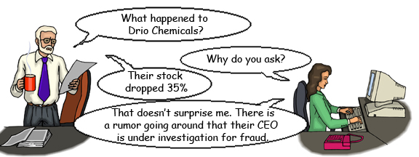
Talking About Stocks |  |  | Talking About Rumors
The stock jumped . . .  The stock dropped . . . |  |  | There is a rumor going around . . .  Rumor has it that . . .  There is some speculation that . . .
Company | Stock Change |  |  | Speculation
 |  | 35% |  | Their CEO is under investigation for fraud.
 |  | 20%
 |  |  |  | They are being bought out by Kingdom Capital.
 |  | 22%
 |  |  |  | They defaulted on their loan.
 |  | 45%
 |  |  |  | They discovered a new oil field.
 |  | 58%
 |  |  |  | They are being sued for environmental damages.

www.bogglesworldesl.com
B sheet There is a Rumor Going Around . . .
Talking About Stocks |  |  | Talking About Rumors
The stock jumped . . .  The stock dropped . . . |  |  | There is a rumor going around . . .  Rumor has it that . . .  There is some speculation that . . .
Company | Stock Change |  |  | Speculation
 |  | 35% |  | Their CEO is under investigation for fraud.
 |  |  |  | They are being sued for negligence.
 |  | 150%
 |  |  |  | They are going to merge with JKL Bank.
 |  | 70%
 |  |  |  | Labor negotiations failed so the steel plants will shut down.
 |  | 250%
 |  |  |  | They are going to be awarded a huge government contract.
 |  | 90%

www.bogglesworldesl.com

